
Spectrum Cloud User Guide
This manual has been written to help you get the most from your Spectrum Cloud.
Please ensure that you read this fully as it contains important information. Failure to follow this advice may result in damage to the panel and invalidate your warranty.
Keep this manual in a safe place for future reference.

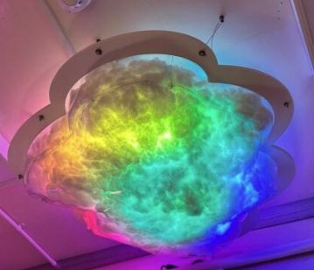

Unpacking
1. Spectrum Clouds are shipped in specialist packaging, designed to protect the panel
from damage during transport.
2. Ensure that the packaging is carefully removed from around the panel. Use scissors with cation to avoid rips in the cloud outer clear fabric.
3. Take care not to lift by the middle panel as this can cause damage. Always lift from the edge.
4. The power supply is stored within the same box (cable ties to be removed).
5. If you find any damage when you unpack you should report it within 7 days to your
supplier.
6. Keep the packaging in case the panel needs to be returned.
Setting up
The Spectrum Cloud must be attached to a solid surface Ceiling (joist etc) using fixings appropriate to the construction of the area. The fitting supplied is a “Ceiling Suspension Kit” due to its durability and simple installation process.
The fittings are already attached to the cloud, please ensure that all fittings are tight around the cloud. Raw plugs have not been provided as each ceiling is different. Therefore, please use an appropriate raw plug to fit on the ceiling.
Each fitting must be attached to the ceiling and should take two people to install.
When adjusting the cable height, ensure that it is out of reach from end users for safety.

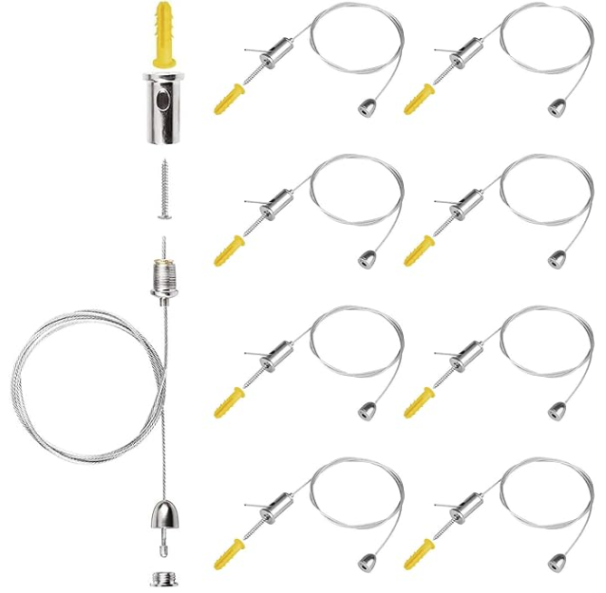

2. Ensure that the power supply is sited at an adequate distance from the panel and that there is no tension in the power cable. The cable should never be coiled around the power supply, as this may cause it to overheat.
3. The Cloud is now ready to use in passive mode.
4. If the Cloud is not wired back to a grid system controller, it is recommended to use a remote-control plug socket (not supplied) if turning off is an issue.

Below Stages Are Only Applicable For An Interactive Cloud
1. When switched on the cloud will automatically go into Rainbow Mode.
2. The button controller plugs into the mains to charge, when charged this unit is wireless and can be turned on and off by a switch at the back of the unit.
3. Corresponding buttons light up and change the panel- red, green, yellow, blue- stays on the colour for 3 seconds, then goes back to rainbow mode.
4. White middle button is the programme button- this does the following:
• rainbow mode
• blue ombre
• green ombre
• rainbow snake
• red and blue meet and bounce

Potential Risks & Warnings
1. Read and understand all these instructions before using the Spectrum Cloud.
2. Do not charge the switchbox with a damaged power cord, or if the unit has been dropped or damaged, have it examined first by qualified service personnel.
3. Position the power cord so that it will not be tripped over, pulled or come into contact with hot surfaces.
4. If an extension lead is necessary, a cable with a current rating at least equal to that of
the tube (3.5A) should be used.
5. Always unplug the switchbox from the power socket before cleaning, servicing and when fully charged. Never yank the cord to Pull the plug from the outlet. Grasp the plug and pull to disconnect.
6. To reduce the risk of electrical shock, do not immerse the product in water or other liquids.
8. Do not dismantle any equipment, but take it to a qualified technician if servicing is
required. Incorrect assembly can cause electrical shock when the product is used
Any questions on assembly, please contact Sense Sensory Ltd.

www.sensesensory.co.uk
01702 810016
info@sensesensory.co.uk

